**Fr. Conceicao Rodrigues College of Engineering**

**DEPARTMENT OF COMPUTER ENGINEERING**

**WEB DESIGN LAB**

**Experiment no 5: JQuery and AJAX**

**POSTLAB**

**CLASS: TE COMPUTERS SEMESTER: V**

**STUDENT NAME: Nash**

**ROLLNO: 8600**

Note:

1. Attempt all the questions.
2. You may use web resources for your study but copy pasting the resources as it is won't earn you marks.
3. Summarize the findings in your own words.
4. Any kind of duplicacy of answers from your peers will lead to strict actions.
5. Paste your codes and screenshot of the output for the lab task given at the bottom.

### What is the use of the css() method in JQuery? Explain with an Example (paste output)

**Ans:**

The css() method sets or returns one or more style properties for the selected elements.

-When used to return properties:

This method returns the specified CSS property value of the FIRST matched element. However, shorthand CSS properties (like "background" and "border") are not fully supported and may give different results in different browsers.

-When used to set properties:

This method sets the specified CSS property for ALL matched elements.

-Syntax:

Return the CSS property value : $(selector).css(property)

Set the CSS property and value : $(selector).css(property,value)

Set CSS property and value using a function :

*$(*selector*)*.css*(*property,function(index,currentvalue))

Set multiple properties and values:

*$(*selector*)*.css({property:value, property:value, ...})

E.g:

<!DOCTYPE html>

<html>

<head>

<script src="https://ajax.googleapis.com/ajax/libs/jquery/3.5.1/jquery.min.js"></script>

<script>

$(document).ready(function(){

$("button").click(function(){

alert($("p").css("color"));

});

});

</script>

</head>

<body>

<button>Color Button</button>

<p style="color:brown">This is a paragraph.</p>

</body>

</html>

**O/P:**

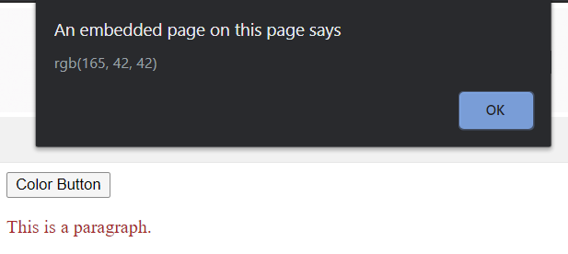

### What are the selectors in jQuery? How many types of selectors in jQuery?

**Ans:**

jQuery selectors allow you to select and manipulate HTML element(s).

jQuery selectors are used to "find" (or select) HTML elements based on their name, id, classes, types, attributes, values of attributes and much more. It's based on the existing [CSS Selectors](https://www.w3schools.com/cssref/css_selectors.asp), and in addition, it has some own custom selectors.

All selectors in jQuery start with the dollar sign and parentheses: $().

There are 3 types of selectors in jQuery:

1. Element Selector - The jQuery element selector selects elements based on the element name.You can select all <p> elements on a page like this : $("p")
2. Id(#) Selector - The jQuery #id selector uses the id attribute of an HTML tag to find the specific element. An id should be unique within a page, so you should use the #id selector when you want to find a single, unique element. To find an element with a specific id, write a hash character, followed by the id of the HTML element : $("#test")
3. Class(.) Selector - The jQuery .class selector finds elements with a specific class.To find elements with a specific class, write a period character, followed by the name of the class:$(“.test”)\

### Mention the Differences between JavaScript and jQuery.

**Ans:**

|  |  |
| --- | --- |
| **Javascript** | **jQuery** |
| It is a weakly typed, dynamic programming language. | jQuery is a concise and fast Javascript library. |
| It is an interpreted language. | It uses resources of javascript to make task simpler and easier. |
| You need to write your own script and it can be a time-consuming process. | You only have to write existing jQuery scripts so it saves time. |
| Too many lines of code. | Fewer lines of code |
| Don’t need to add any additional plugins as all browsers support Javascript | You may have to include jQuery library URL in the header of the page. |

### What are the features of jQuery?

**Ans:**

* **Simple and easy:** It have predefined method using you can perform any task easily compare to JavaScript. And it is easy to learn.
* **Lightweight:** It is very lightweight library - about 19KB in size ( Minified and gzipped ).
* **CSS manipulation:** It have predefined css() method for manipulate style for any Html elements.
* **Html manipulation:** The jQuery made it easy to select DOM elements, traverse them and modifying their content.
* **Cross browser support:** It support all modern web-browser including IE-6.
* **Event handling:** It support event handling like click mouse button.
* **JavaScript Library:** It is JavaScript library.
* **Ajax Support:** It support ajax, you can develop a responsive and feature-rich site using AJAX technology.
* **Built-in Animation:** It have predefined method "animate()" for create custom animation on web-page.

### What are the advantages of AJAX?

**Ans:**

* **Speed :** Reduce the server traffic in both side's request and also reduce the time consuming on both side response.
* **Interaction :** AJAX is much responsive, whole page data transfers at a time.
* **XMLHttpRequest :** XMLHttpRequest object call as an asynchronous HTTP request to the Server for transferring data both sides. It is used for sending requests to the non-Ajax pages.
* **Asynchronous calls :** AJAX make asynchronous calls to a web server. This means that client browsers avoid waiting for all data to arrive before starting the rendering.
* **Form Validation :** This is one of the biggest advantages of AJAX. Forms are a common element in a web page. Validation should be instant and proper, which is provided by AJAX.
* **Bandwidth Usage :** AJAX helps to improve speed and performance. Fetching data from the database and storing data into the database is performed in the background without reloading page.

1. One of the demerits of AJAX is the redundant flow of requests. How can we hope to tackle simultaneous requests in AJAX?

**Ans:**

In order to tackle concurrent requests, the respective Java script functions need to be written. Having written the functions, the call back function can be applied as a parameter in order to tackle simultaneous requests. The concerned parameters are then passed to what is known as the AjaxInteraction object in order to tackle the concurrency of incoming requests.

1. What are the differences between AJAX and Javascript?

**Ans:**

|  |  |
| --- | --- |
| **AJAX** | **Javascript** |
| AJAX allows the coder send request data asynchronously in order to load new data without changing the web page. | Javascript is a client-side scripting language that allows the creation of dynamic web pages by providing a new level of interactivity. |
| AJAX supports the server side scripting language. | Javascript provides support to the client side scripting language. |
| AJAX can load the web page after it is been loaded for the first time. | Javascript cannot the load the pages after it is once loaded. |
| AJAX does not install trojan in the computer. | Javascript can install trojan in the computer. |

**\*\*\*\*\*\*\*\*\*\*\*\*\*\*\*\*\*\*\*\*\*\*\*\*\*\*\*\*\*\*\*\*\*\*\*\*\*\*\*\*\*\*\*\*\*\*\*\*\*\*\*\*\*\*\*\*\*\*\*\*\*\*\*\*\*\***

**Lab Task**

**\*\*\*\*\*\*\*\*\*\*\*\*\*\*\*\*\*\*\*\*\*\*\*\*\*\*\*\*\*\*\*\*\*\*\*\*\*\*\*\*\*\*\*\*\*\*\*\*\*\*\*\*\*\*\*\*\*\*\*\*\*\*\*\*\*\***

1. **Create a simple game using HTML5 , CSS Javascript and Jquery**

Note: you can create games like:

1. TIC TAC TOE
2. SNAKE GAME
3. TYPING GAME
4. GUESSING GAMES
5. MATHEMATICAL GAMES
6. PUZZLE GAMES
7. PONG
8. TETRIS
9. First Person shooting Games

Upload the entire game code as a separate attachment in the attachment tab.

-done

Upload the entire code on Github and provide the url for the game code:

-https://github.com/Nashdodti/tictac

Paste the game screenshot here

-https://tictac20.netlify.app/

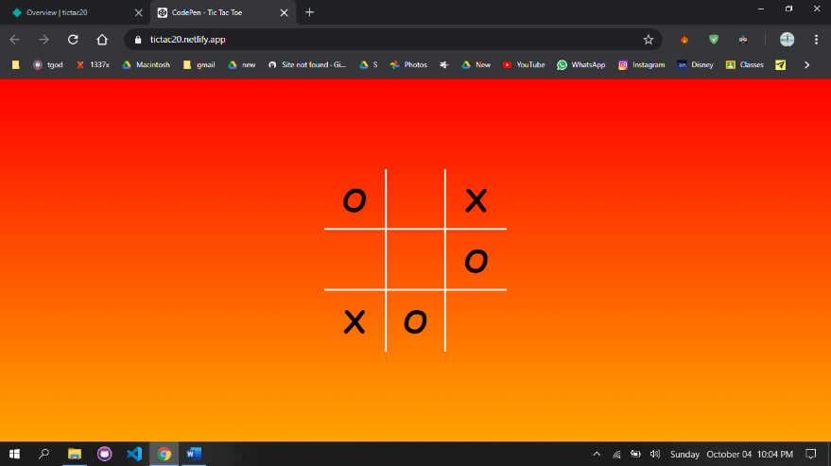

2. **Populate state dropdown based on option selected in country dropdown using jQuery and AJAX calls**

**Note: the state data for every country must be in a text file or you can use an XML file for the same. (minimum entries 5 countries and 10 state per country)**

**Sample output:**

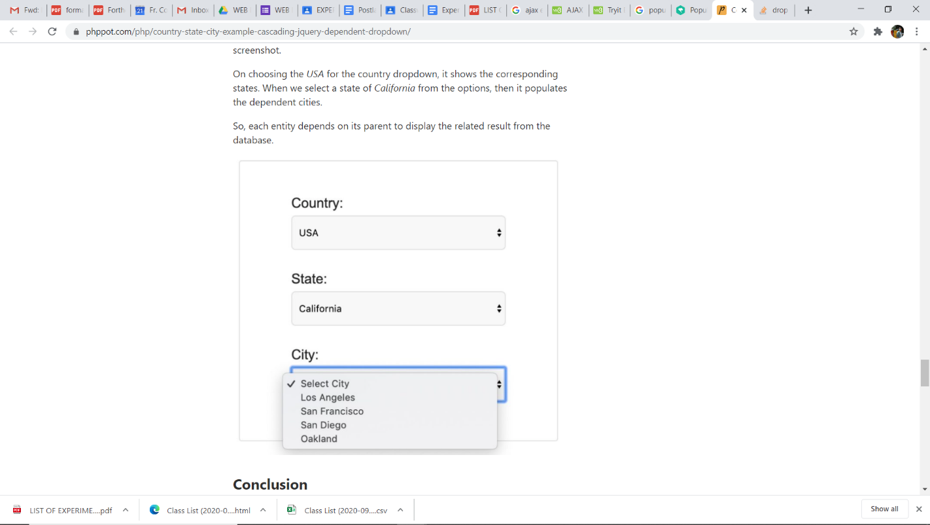

Upload your code as a separate attachment in the attachment tab for this assignment

Paste the screenshot of your output here: